Project Document On

**Customer Help Desk With Smart Document**

**Understanding**

**Name**  : Nikita Kukreja

|  |  |  |
| --- | --- | --- |
| **Internship** **Title** | : | Intelligent Customer Help Desk with Smart Document Understanding - SB7934 |
| **Project ID** | : | SPS_PRO_99 |
| **Project Title** | : | Intelligent Customer Help Desk with Smart Document Understanding |

**TABLE OF CONTENTS**

1. Project Summary ……………………………………………………………………………………………………….. 3

2. Project Requirements ……………………………………………………………………………………………………….. 3

3. Functional Requirements ………………………………………………………………………………………………………. 4

4. Technical Requirements ………………………………………………………………………………………………………. 4

5. Software Requirements ………………………………………………………………………………………………………. 5

6. Project Deliverables ---------------------------------------------------------------------------------------- 5

7. Project Team …………………………………………………………………………………………………….. 6

8. Project Schedule ……………………………………………………………………………………………………… 6

**Project Summary**

The typical customer care chatbot can answer simple questions, such as store locations and hours, directions, and maybe even making appointments. When a question falls outside of the scope of the pre-determined question set, the option is typically to tell the customer the question isn’t valid or offer to speak to a real person.

In this project, there will be another option. If the customer question is about the operation of a device, the application shall pass the question onto Watson Discovery Service, which has been pre-loaded with the device’s owners manual. So now, instead of “Would you like to speak to a customer representative?” we can return relevant sections of the owners manual to help solve our customers’ problems.

To take it a step further, the project shall use the Smart Document Understanding feature of Watson Discovery to train it on what text in the owners manual is important and what is not. This will improve the answers returned from the queries.

**Project Requirements**

* Explore IBM Cloud Platforms
* Explore IBM Watson Services
* Explore IBM Cloud Functions
* Customer Help Desk With Smart Document Understanding

**Functional Requirements**

1. The document is annotated using Watson Discovery Smart Document Understanding.
2. The user interacts with the back-end server via the app UI. The front-end app UI is a chatbot that engages the user in a conversation.
3. Dialog between the user and back-end server is coordinated using a Watson Assistant dialog skill.
4. If the user asks a product operation question, a search query is passed to a predefined IBM Cloud Functions action.
5. The IBM Cloud Functions action will query the Watson Discovery Service and return the results.

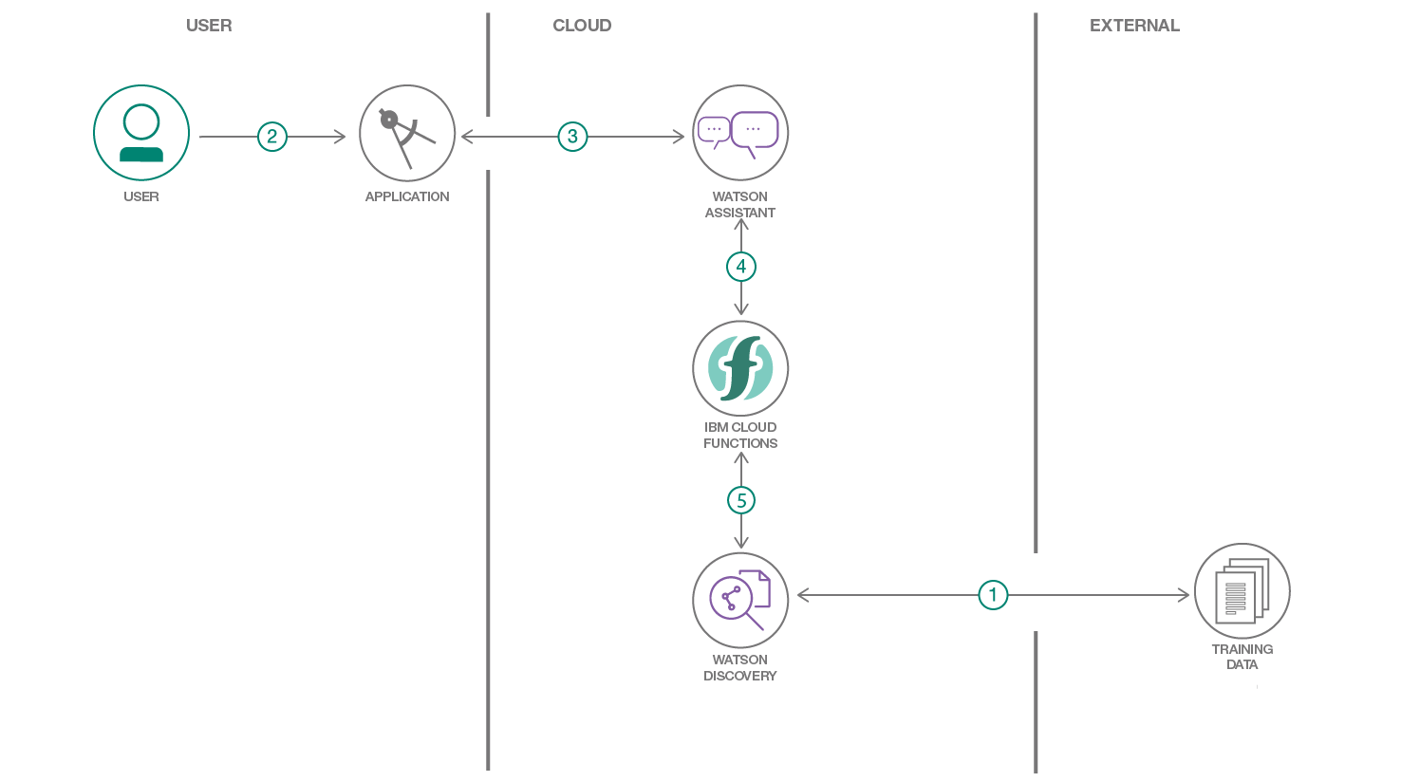

**Technical Requirements**

* Create a customer care dialog skill in Watson Assistant
* Use Smart Document Understanding to build an enhanced Watson Discovery collection
* Create an IBM Cloud Functions web action that allows Watson Assistant to post queries to Watson Discovery
* Build a web application with integration to all these services & deploy the same on IBM Cloud Platform

**Software Requirements**

Python, IBM Cloud, IBM Watson

**Project Deliverables**

Using Watson Assistant, IBM Cloud Functions, and Watson Discovery Smart Document Understanding to create a webhook chatbot

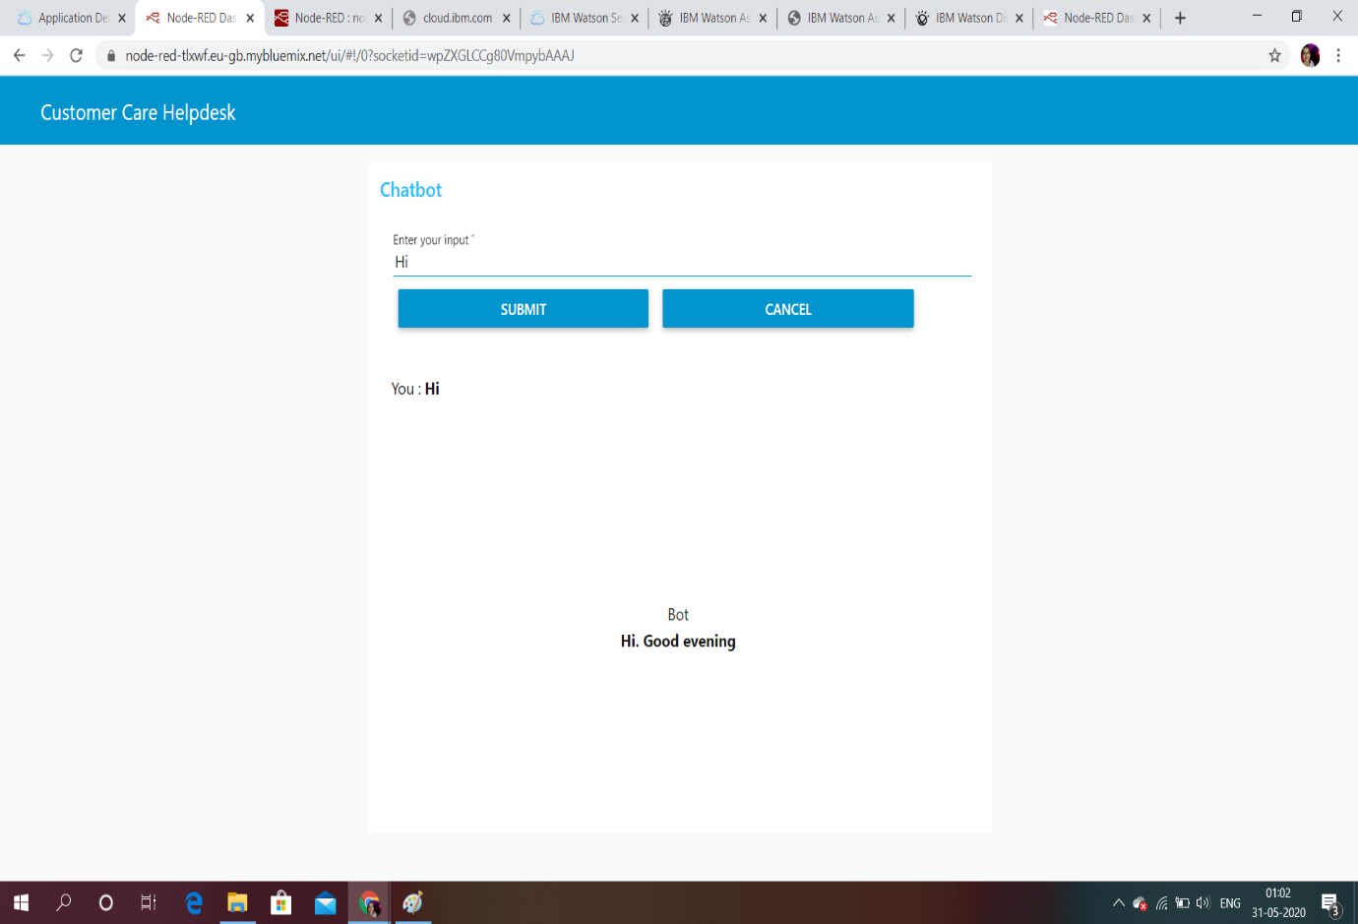

**Project Team**

Nikita N. Kukreja

**Project Schedule**

5 May 2020 – 5 June 2020